Design and MATLAB Implementation of a Device Communication Plan for Long-Life Sensor Network
1. Introduction
Wireless Sensor Networks (WSNs) are an important part of modern Internet of Things (IoT) applications. They consist of many small sensor nodes that collect environmental information such as temperature, humidity, pressure, vibration, and motion. These sensor nodes communicate wirelessly with a central Base Station (BS), which processes the collected data and forwards it to monitoring systems.
One of the major challenges in wireless sensor networks is limited battery life. Since most sensor nodes operate using batteries and are deployed in remote or inaccessible locations, replacing batteries frequently is difficult and expensive. Therefore, the communication system should be designed to consume minimum energy while maintaining reliable data transmission.
The proposed communication plan uses Orthogonal Frequency Division Multiple Access (OFDMA) for efficient resource allocation. Each sensor node is assigned a dedicated Resource Block (RB), reducing interference and avoiding collisions during communication. The nodes remain in sleep mode when they are not transmitting data, which significantly reduces unnecessary power consumption. The communication power is also adjusted based on the distance between the sensor node and the Base Station, further improving energy efficiency.
The proposed design is implemented and validated using MATLAB by calculating the energy consumed by each node, remaining battery energy, path loss, and estimated network lifetime.

2. Proposed Device Communication Plan
The proposed system consists of ten wireless sensor nodes, one Base Station, and an IoT monitoring platform. Each sensor periodically measures environmental data and sends it to the Base Station using OFDMA communication.
The communication process follows these steps:
- Sensor nodes remain in sleep mode to conserve battery.
- At predefined intervals, a node wakes up and senses data.
- The Base Station assigns an OFDMA Resource Block to the node.
- The node transmits data using minimum transmission power.
- Path loss is calculated according to the distance between the sensor and the Base Station.
- Energy consumed during transmission is computed.
- Remaining battery energy is updated.
- The Base Station receives data from all sensor nodes and forwards it to the monitoring application.
This communication strategy minimizes collisions, reduces idle listening, and extends the lifetime of the sensor network.
System Architecture
Sensor Nodes

OFDMA Resource Block Allocation

Wireless Communication

Base Station

IoT Monitoring System
3. MATLAB Design Methodology
The MATLAB simulation models the communication behaviour of a long-life sensor network.
The following assumptions are made:
- Number of sensor nodes = 10
- Initial battery energy = 100 Joules
- Number of OFDMA Resource Blocks = 5
- Transmission power = 0.5 W
- Packet transmission time = 0.05 s
- Sensor distance from Base Station = 20–200 m
The simulation performs the following operations:
- Generates random distances for sensor nodes.
- Assigns OFDMA Resource Blocks.
- Calculates path loss for every node.
- Computes transmission energy.
- Updates remaining battery energy.
- Estimates communication lifetime.
- Displays graphs for distance, energy consumption, remaining battery, and Resource Block allocation.
Mathematical Model
Path Loss
PL = 32.4 + 20 log10(d)
where:
- PL = Path Loss (dB)
- d = Distance between sensor node and Base Station (m)
Energy Consumption
E = P × t × (d / 200)
where:
- E = Energy consumed
- P = Transmission power
- t = Packet transmission time
Remaining Battery
Battery Remaining = Initial Battery − Energy Used
4. MATLAB Implementation
clc;
clear;
close all;
numNodes = 10;
batteryEnergy = 100 * ones(1,numNodes);
distance = randi([20 200],1,numNodes);
resourceBlocks = 5;
txPower = 0.5;
packetTime = 0.05;

fprintf('LONG-LIFE SENSOR NETWORK COMMUNICATION PLAN\n\n');
for i=1:numNodes
RB(i)=mod(i-1,resourceBlocks)+1;
pathLoss(i)=32.4+20*log10(distance(i));
energyUsed(i)=txPower*packetTime*(distance(i)/200);
batteryRemaining(i)=batteryEnergy(i)-energyUsed(i);
lifetime(i)=batteryRemaining(i)/energyUsed(i);
end
disp('Node Distance RB EnergyUsed Battery');
for i=1:numNodes
fprintf('%2d %8d %4d %10.3f %10.2f\n',...
i,distance(i),RB(i),energyUsed(i),batteryRemaining(i));
end
figure;
subplot(2,2,1)
bar(distance)
title('Distance')
subplot(2,2,2)
bar(energyUsed)
title('Energy Used')
subplot(2,2,3)
bar(batteryRemaining)
title('Remaining Battery')
subplot(2,2,4)
bar(RB)
title('Resource Block Allocation')

OUTPUT:
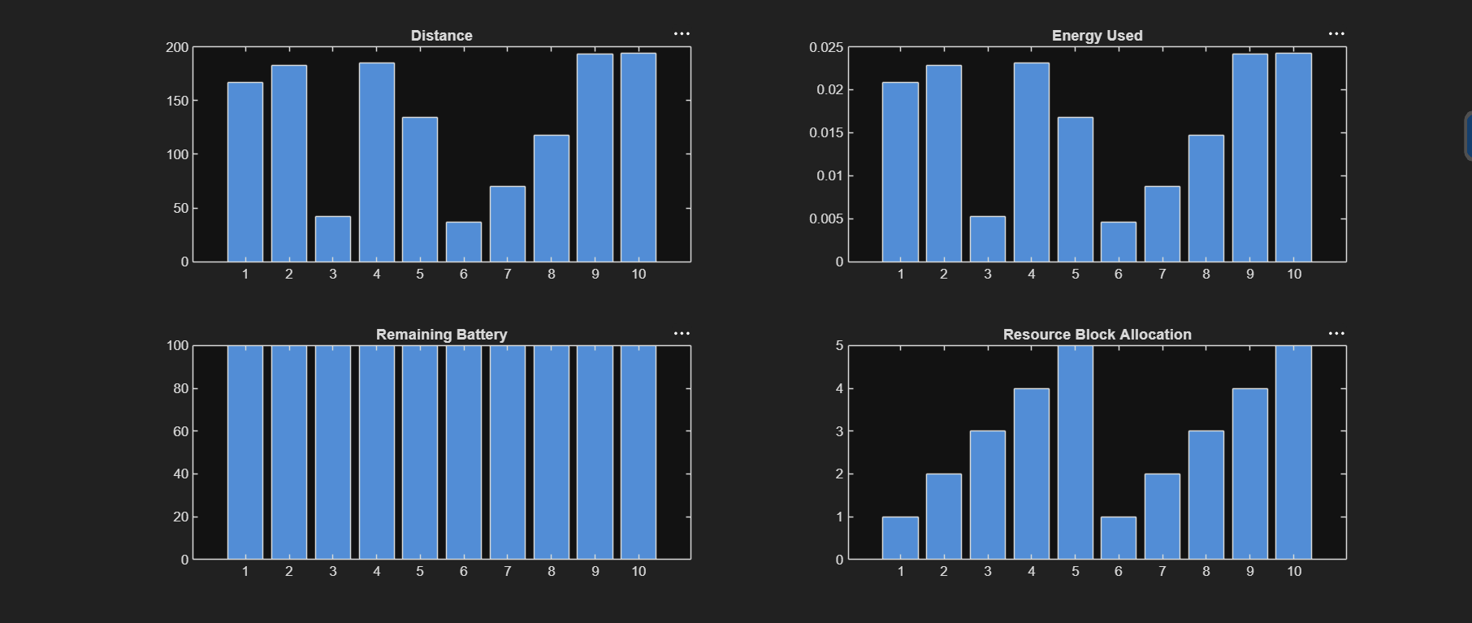5. Results and Conclusion
The MATLAB simulation successfully demonstrates an energy-efficient communication strategy for long-life wireless sensor networks. Each sensor node is assigned an OFDMA Resource Block, allowing multiple nodes to communicate without interference. The simulation calculates the energy consumed during each transmission and updates the remaining battery level of every sensor node.
The graphical results show the variation in sensor distances, energy consumption, battery status, and Resource Block allocation. Nodes located farther from the Base Station consume slightly more energy due to higher path loss, while nearby nodes require less transmission power. The sleep mode operation and OFDMA scheduling significantly reduce unnecessary communication overhead, increasing the estimated network lifetime.
Advantages
- Extends sensor battery life.
- Efficient OFDMA Resource Block allocation.
- Reduces communication interference.
- Low power consumption.
- Suitable for IoT and smart monitoring applications.
- Easy to implement and analyse using MATLAB.
Applications
- Smart Agriculture
- Healthcare Monitoring
- Industrial IoT
- Environmental Monitoring
- Smart Cities
- Forest Fire Detection
Conclusion
A communication plan for long-life sensor networks was designed and implemented using MATLAB. The proposed approach combines OFDMA resource allocation, low-power communication, and battery monitoring to improve the operational lifetime of sensor nodes. The simulation verifies that efficient resource management reduces energy consumption while maintaining reliable wireless communication, making the proposed design suitable for modern IoT-based wireless sensor network applications.

